Dataset
rnd_room_c2_02:
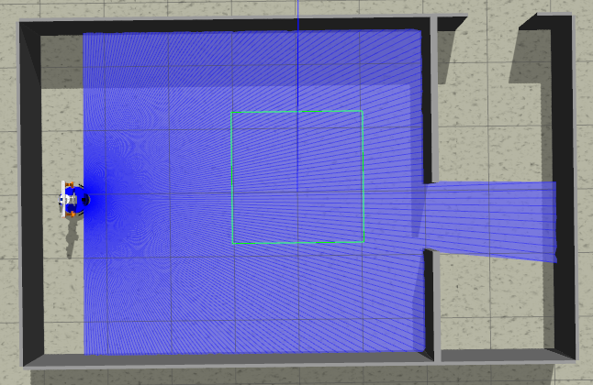
samples
1)
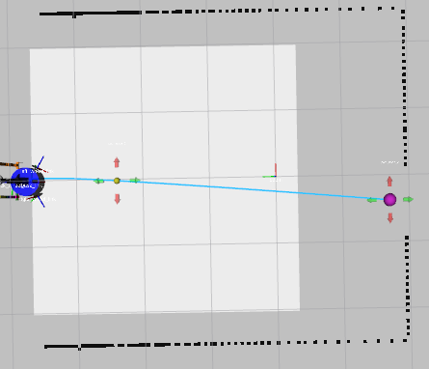
linea recta a puerta 5.4m (x3) (0.0 3.7 -1.57075) to (-0.38, -1.7)
files: data_from_path_2025-02-26_13-50-54 to data_from_path_2025-02-26_13-52-05

2)
inea recta a puerta 5.4m (x3) (0.0 3.7 1.57075) to (-0.38, -1.7)
files: data_from_path_2025-02-26_13-54-43 to data_from_path_2025-02-26_13-57-51

3)
inea recta a puerta 5.4m (x2) (0.0 3.7 0) to (-0.38, -1.7)
files: data_from_path_2025-02-26_13-59-53 to data_from_path_2025-02-26_14-00-19

4)
inea recta a puerta 5.4m (x2) (0.0 3.7 PI) to (-0.38, -1.7)
files: data_from_path_2025-02-26_14-01-36 to data_from_path_2025-02-26_14-01-53

5)
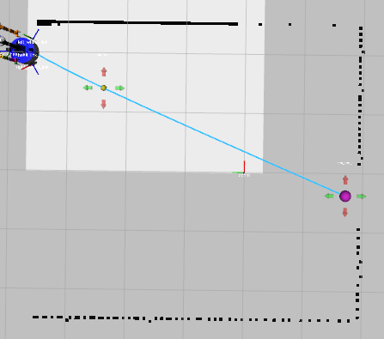
esq inf izq a puerta 5.9m (x3) (2.1 3.7 -1.57075) to (-0.38, -1.7)
files: data_from_path_2025-02-26_14-07-34 to data_from_path_2025-02-26_14-08-13

6)
esq inf izq a puerta 5.9m (x3) (2.1 3.7 1.57075) to (-0.38, -1.7)
files: data_from_path_2025-02-26_14-11-31 to data_from_path_2025-02-26_14-13-28

7)
esq inf izq a puerta 5.9m (x2) (2.1 3.7 0) to (-0.38, -1.7)
files: data_from_path_2025-02-26_14-14-35 to data_from_path_2025-02-26_14-14-54

8)
esq inf izq a puerta 5.9m (x2) (2.1 3.7 PI) to (-0.38, -1.7)
files: data_from_path_2025-02-26_14-16-05 to data_from_path_2025-02-26_14-16-27

9)
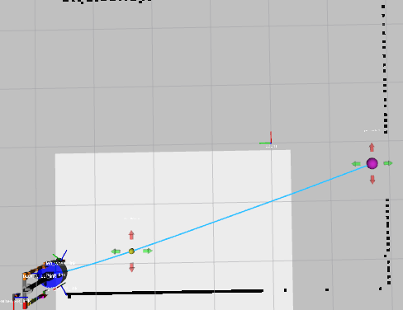
esq inf der a puerta 5.9m (x3) (-2.1 3.7 -1.57075) to (-0.38, -1.7)
files: data_from_path_2025-02-26_14-19-35 to data_from_path_2025-02-26_14-20-21

10)
esq inf der a puerta 5.7m (x3) (-2.1 3.7 1.57075) to (-0.38, -1.7)
files: data_from_path_2025-02-26_14-22-36 to data_from_path_2025-02-26_14-23-32

11)
esq inf der a puerta 5.7m (x2) (-2.1 3.7 0) to (-0.38, -1.7)
files: data_from_path_2025-02-26_14-24-54 to data_from_path_2025-02-26_14-25-13

12)
esq inf der a puerta 5.7m (x2) (-2.1 3.7 PI) to (-0.38, -1.7)
files: data_from_path_2025-02-26_14-26-36 to data_from_path_2025-02-26_14-26-56

13)
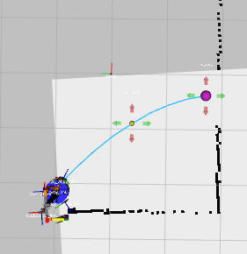
centro der a puerta 3.2m (x3) (-2.1 1 -1.57075) to (-0.38, -1.7)
files: data_from_path_2025-02-26_14-29-36 to data_from_path_2025-02-26_14-30-08

14)
centro der a puerta 3.2m (x3) (-2.1 1 1.57075) to (-0.38, -1.7)
files: data_from_path_2025-02-26_14-33-52 to data_from_path_2025-02-26_14-34-21

15)
centro der a puerta 3.2m (x2) (-2.1 1 0) to (-0.38, -1.7)
files: data_from_path_2025-02-26_14-35-33 to data_from_path_2025-02-26_14-35-47

16)
centro der a puerta 3.2m (x2) (-2.1 1 PI) to (-0.38, -1.7)
files: data_from_path_2025-02-26_14-41-48 to data_from_path_2025-02-26_14-42-29

17)
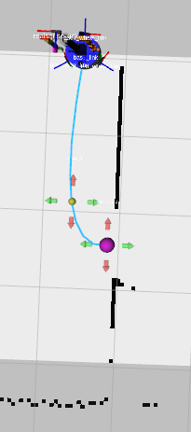
esq sup izq a puerta 2.5m (x2) (2.1 -1.5 PI) to (-0.38, -1.7)
files: data_from_path_2025-02-26_14-50-55 to data_from_path_2025-02-26_14-51-15

18)
esq sup izq a puerta 2.5m (x2) (2.1 -1.5 0) to (-0.38, -1.7)
files: data_from_path_2025-02-26_14-52-25 to data_from_path_2025-02-26_14-52-40

19)
esq sup izq a puerta 2.5m (x2) (2.1 -1.5 -1.57075) to (-0.38, -1.7)
files: data_from_path_2025-02-26_14-53-20 to data_from_path_2025-02-26_14-53-34

20)
esq sup izq a puerta 2.5m (x2) (2.1 -1.5 1.57075) to (-0.38, -1.7)
files: data_from_path_2025-02-26_14-54-08 to data_from_path_2025-02-26_14-54-24

21)
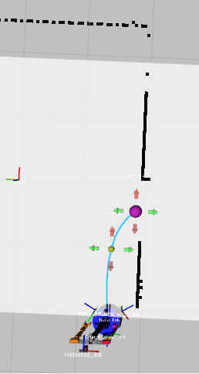
esq sup der a puerta 1.7m (x2) (2.1 -1.5 0) to (-0.38, -1.7)
files: data_from_path_2025-02-26_15-14-40 to data_from_path_2025-02-26_15-14-54

22)
esq sup der a puerta 1.7m (x2) (2.1 -1.5 PI) to (-0.38, -1.7)
files: data_from_path_2025-02-26_15-17-01 to data_from_path_2025-02-26_15-17-38

23)
esq sup der a puerta 1.7m (x2) (2.1 -1.5 -1.57075) to (-0.38, -1.7)
files: data_from_path_2025-02-26_15-18-21 to data_from_path_2025-02-26_15-18-33

24)
esq sup der a puerta 1.7m (x2) (2.1 -1.5 1.57075) to (-0.38, -1.7)
files: data_from_path_2025-02-26_15-19-11 to data_from_path_2025-02-26_15-19-22

25)
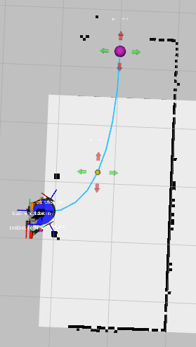
puerta a puerta 3m (x3) (-0.5 -1.8 -1.57075) to (2.48, -3.0)
files: data_from_path_2025-02-26_15-28-54 to data_from_path_2025-02-26_15-29-28

26)
puerta a puerta 3m (x3) (-0.5 -1.8 1.57075) to (2.48, -3.0)
files: data_from_path_2025-02-26_15-30-11 to data_from_path_2025-02-26_15-30-44

-----
Mirror
-----
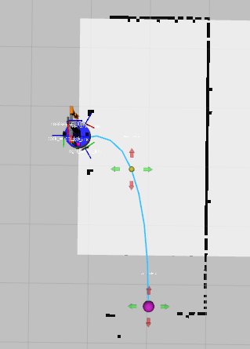
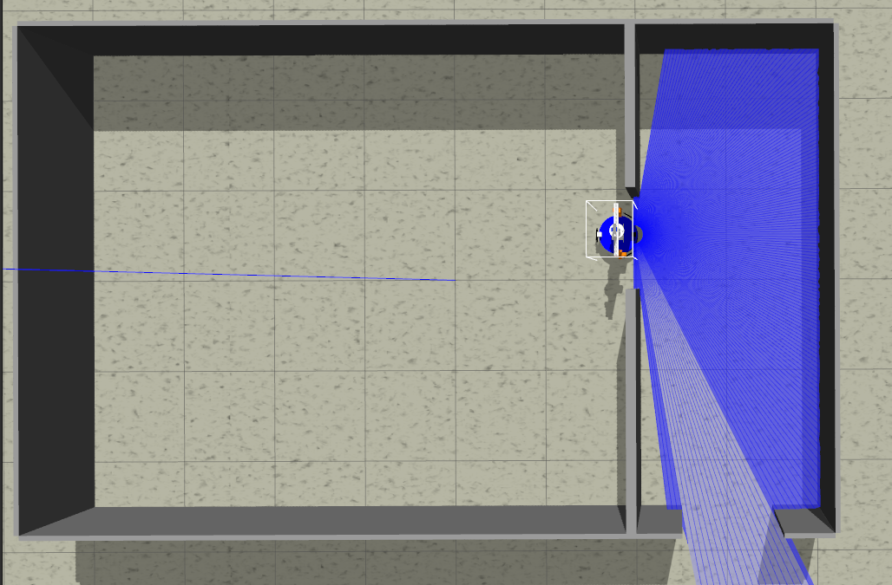

27)
puerta a puerta 3m (x3) (0.5 -1.8 -1.57075) to (2.48, -3.0)
files: data_from_path_2025-02-26_15-44-59 to data_from_path_2025-02-26_15-45-30

28)
puerta a puerta 3m (x3) (0.5 -1.8 1.57075) to (2.48, -3.0)
files: data_from_path_2025-02-26_15-46-06 to data_from_path_2025-02-26_15-46-42

